R u n n i n g f o r t h e B o a r d ? 


In order for your application to be accepted when you decide to run for election to the City Park Board the following criteria must be met

✪ | You must completely fill out the nomination form that is available from the office and returned it to the office along with your picture and short bio. by the closing on August 23, 2019 at 3:30 pm.
✪ | ORGANIZATIONAL BY-LAW No, 2  2.5 Member in Good Standing In order to be in good standing a Member may not be in arrears, on a performance agreement, breach confidentiality as a Director or committee Member (Section 11.2), or be found to be in serious dereliction of duty as a Member or Director. Such behaviour includes, but not limited to: conflict of interest, criminal activity, compromising the safety of Members, harassment, misrepresentation, damage to Co-op  6.3 Qualifications to Act as a Director (a) No person shall act as a Director of the Co-op unless that person is eighteen years of age or over and is a Member of the Co-op who has been a Member for at least twelve (12) consecutive months up to the cut-off date for nominations as defined in paragraph 6.5 of this by-law. A majority of Directors shall be Canadian citizens or landed immigrants. No person who is an undischarged bankrupt or has been deemed unable to manage their property as determined under the Substitute Decisions Act shall qualify to act as a Director. In addition no person who is litigating against the Co-op or who is being litigated against by the Co-op may act as a Director. No Director may be in arrears as according to Bylaw 3 Schedule L: Arrears Policy.
Other By-Laws may be applied.

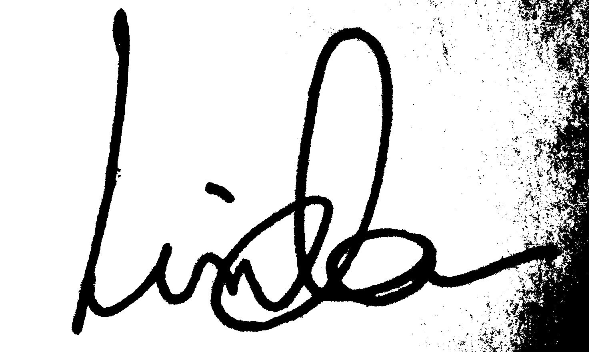
Linda Gallant, Director

